**ST. XAVIER’S COLLEGE**

**Maitighar, Kathmandu**

**DATABASE MANAGEMENT SYSTEM**

**THEORY ASSIGNMENT #5**

**Submitted by**

Anu Kadel

013BSCCSIT007

**Submitted to:**

Mr. Sanjay Kumar Yadav

(Lecturer)

Department of Computer Science And Information Technology

(St.Xavier’s College)

**THEORY ASSIGNMENT#5**

**Entity Relationship model**

1. What do you mean by Entity- Relationship Diagram? Explain

An entity-relationship model (ERM) is a theoretical and conceptual way of showing data relationships in software development. ERM is a database modeling technique that generates an abstract diagram or visual representation of a system’s data that can be helpful in designing a relational database. These diagrams are known as entity-relationship diagrams, ER diagrams or ERDs.

ER-Diagram is a visual representation of data that describes how data is related to each other.

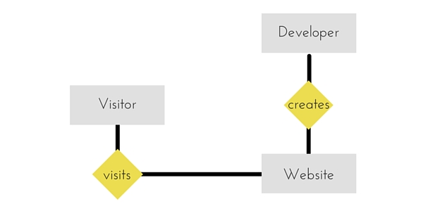

1. Define entity and give an example.

An entity is a real-world item or concept that exists on its own. In ER model, we diagram an entity type as a rectangle containing the type name, such as employee in given diagram.

In a logical sense, entities are the equivalent of grammatical nouns, such as employees, departments, products, or networks.

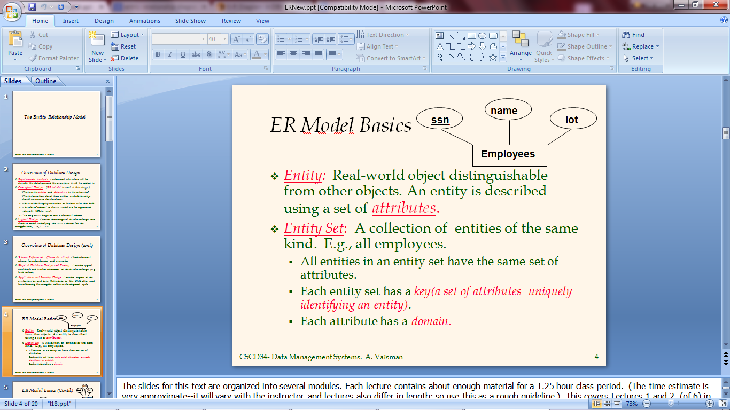

1. Explain the different between an entity class and an entity instance.

An entity is a person, place, event, or thing about which data is collected...An instance is an occurrence of an entity.

Entity instance is a single occurrence of an entity type. Also known as an instance. Unlike entity type, many instances of entity type may be represented by data stored in the database.

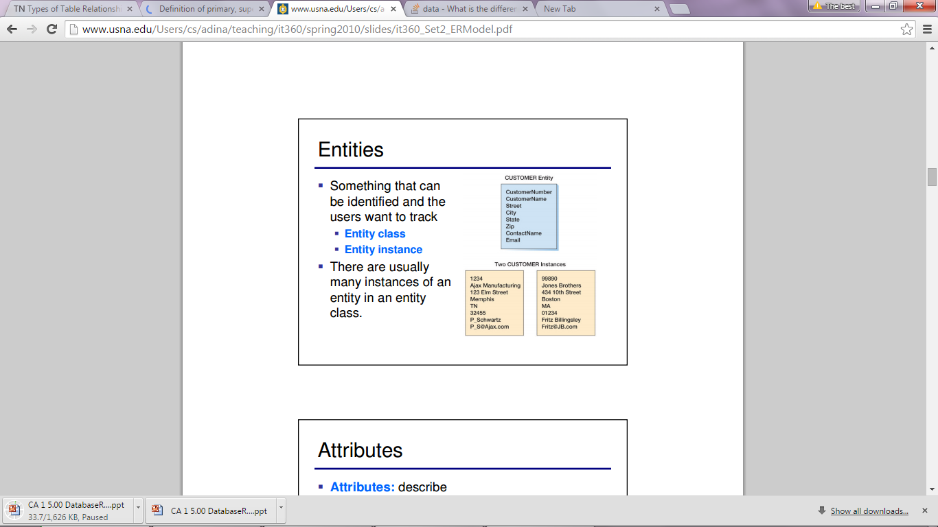

1. Define attribute and its types.

An **Attribute** describes a property or characteristic of an entity. For example, Name, Age, Address etc can be attributes of a Student. An attribute is represented using eclipse.

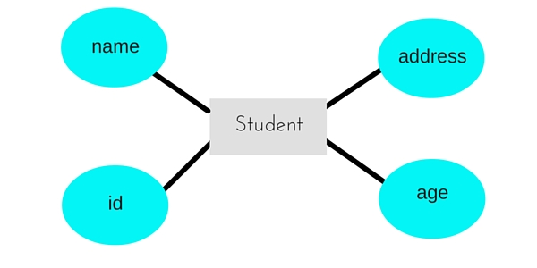

**Key attribute** represents the main characteristic of an Entity. It is used to represent Primary key. Ellipse with underlying lines represents Key Attribute

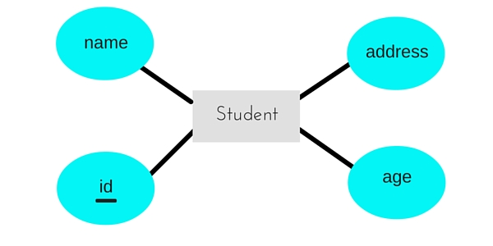

[5].What is derived attributes?

[6]. Define relationship and give an example.

A Relationship describes relations between **entities**. Relationship is represented using diamonds

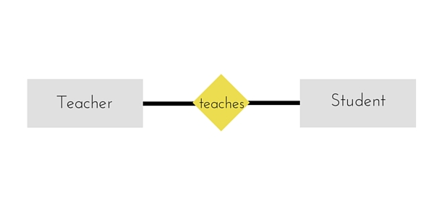

7. Explain the difference between a relationship class and a relationship instance.

8. Define degree of relationship.

9. List and give an example of the three types of binary relationships. Draw an E-R diagram

for each.

10. Define the terms maximum cardinality and minimum cardinality.

In database design, the **cardinality** or fundamental principle of one data table with respect to another is a critical aspect. The relationship of one to the other must be precise and exact between each other in order to explain how each table links together.

In the relational model, tables can be related as any of "one-to-many" or "many-to-many." This is said to be the **cardinality** of a given table in relation to another

**Maximum cardinality:** Maximum number of an entity instances that can participate in a relationship

1. One to one
2. One to many
3. Many to many

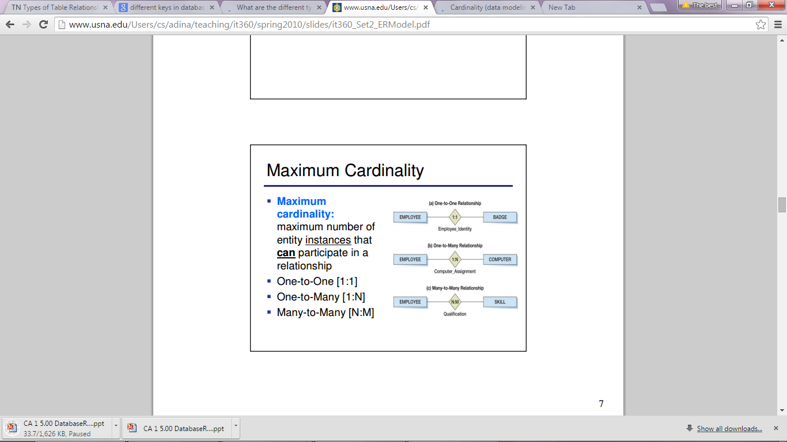

**Minimum cardinality:** Minimum number of entity instances that must participate in a relationship

1. Zero[0] optimal
2. One[1] mandatory

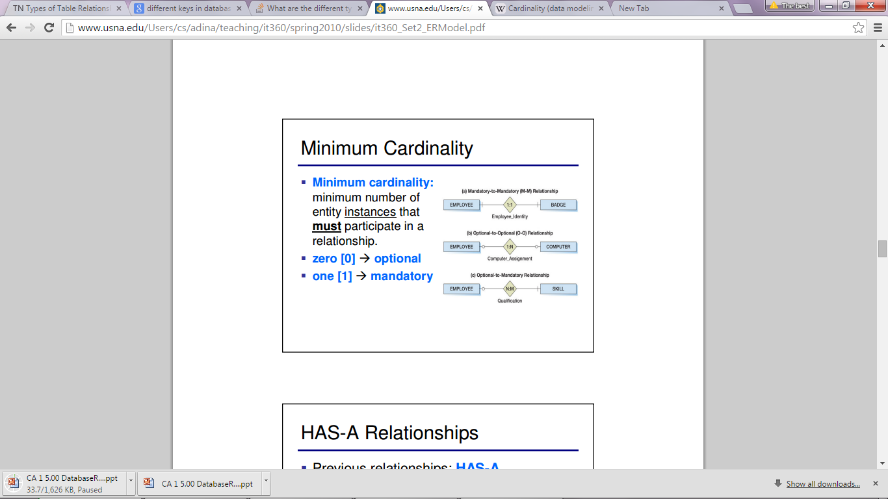

[11]. Explain the distinctions among the terms primary key, candidate key and super key.

* **Candidate key** - A candidate key is a field or combination of fields that can act as a primary key field for that table to uniquely identify each record in that table.

E.g. of Candidate Key

1. ID
2. Name, Address

For above table we have only two Candidate Keys,. ID Key can identify the record uniquely and similarly combination of Name and Address can identify the record uniquely, but neither Name nor Address can be used to identify the records uniquely as it might be possible that we have two employees with similar name or two employees from the same house.

* **Primary key -** a primary key is a value that can be used to identify a unique row in a table. Attributes are associated with it. Examples of primary keys are Social Security numbers (associated to a specific person) or ISBNs (associated to a specific book). In the relational model of data, a primary key is a candidate key chosen as the main method of uniquely identifying a tuple in a relation.

E.g. of Primary Key - Database designer can use one of the Candidate Key as a Primary Key. In this case we have “ID” and “Name, Address” as Candidate Key, we will consider “ID” Key as a Primary Key as the other key is the combination of more than one attribute.

* **Super key** - A superkey is defined in the relational model as a set of attributes of a relation variable for which it holds that in all relations assigned to that variable there are no two distinct tuples (rows) that have the same values for the attributes in this set.

E.g. of Super Key

1. ID
2. ID, Name
3. ID, Address
4. ID, Department_ID
5. ID, Salary
6. Name, Address
7. Name, Address, Department_ID

So on as any combination which can identify the records uniquely will be a Super Key.

12. What are the main building modules of the entity relationship model? Discuss each one.

13. What is composite attributes, when it is used?

An attribute can also have their own attributes. These attributes are known as **Composite** attribute. 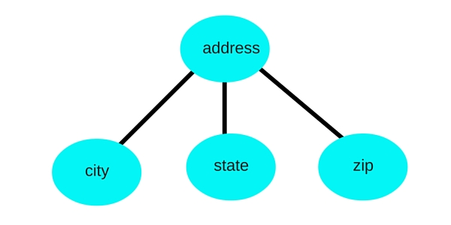

14. Explain the difference between single-value attributes and simple attributes.

15. Discuss the difference between a composite key and a composite attribute. How would

each indicated in an E-R diagram?

16. What two courses of action are available to a designer when a multivalued attribute is

encountered ?

17. Explain the various terms of an E-R model and how are they represented in an E-R

model?

18. Explain the concept of dependent entities? Give example.

19. What is the difference total and partial participation? Explain.

20. What do you mean by mapping cardinalities ? explain various type of cardinalities.

21. What is the difference between single-value and multivalued attributes? Explain

22. Explain the concept of participation constraints.

23. Difference the binary relationship with ternary relationship with example.

24. Explain the difference between weak and strong entity set.

25. Define the components of extended E-R features.

26. Define the concept of aggregation. Give two examples of where this concept is useful.

27. Explain the distinction between disjoint and overlapping constraints.

28. Explain the distinction between total and partial constraints.

29. Write short notes on:

• Specialization

• Generalization

• Aggregation